
Introduction to Bike Repair Week 6:

Headsets

Headset Introduction
The headset is the set of bearings that connects your fork to to your frame and rotates to allow your fork to steer. There are two types of headset:
- Threaded: This is an older type of headset that has a loose bearing that are held in place by a locknut that screws onto the steerer tube. This type of headset works in a similar fashion to your wheel hub. The steerer tube extends to the top of the headset and the stem (quill style) fits into the steerer tube.
- Threadless: This type of head set has bearings that are held in place by the stem via pinch bolts on the stem that go around the steerer tube.

Headset Sizing
Headset size is based on the outside diameter of the steerer tube. There are 2 common sizes of headsets:
- 1-inch: This size is typically found on threaded headsets. The steerer tube will be slightly smaller than a quarter.
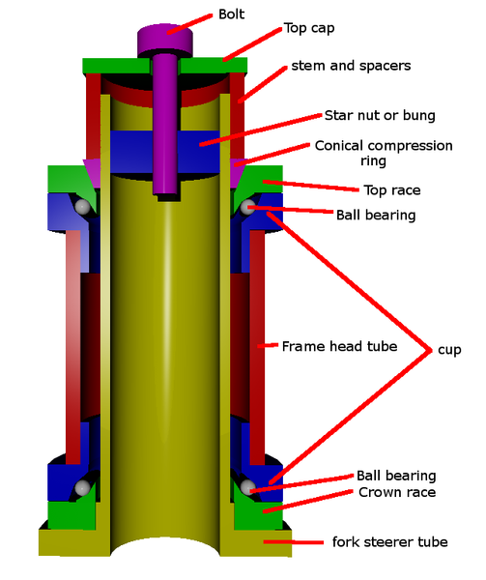Threadless Headset [a]
- 1.125-inch (1 1/8”): This size is typically found on threadless headsets. The steerer tube will be slightly larger than a quarter.

Threadless Headset Servicing and Bearing replacement [c]
- Remove the pre-load adjustment bolt on the top of the steerer tube. Also remove the top cap and any spacers that are above the stem.
- Make sure that the fork is supported and loosen the bolts clamping the stem to the steerer tube. The fork may now be removed.
- Remove the conical compression ring and bearings.
- Clean and inspect the bearings and races. If the bearings or races do not need to be replaces skip to step 9.
- Remove the bearing cups with a headset cup removal tool.
- Remove the crown race (if necessary) from the fork with a crown race removal tool, or a hammer and punch. Be careful not to damage the crown race if it will be reused.
- Install a new crown race with a crown race installation tool
- Install the cups with a bearing press.
- Grease the bearings, crown race and cups with heavy grease.
- Install the bearing and compression rings.
- Replace the fork and set the stem on it.
- Install a new star nut if necessary and thread the pre-load bolt through the end cap and into the star nut.
- Tighten the pre-load bold until there is not play in the bearings, but not tighter. This can be checked by rocking the bike back and forth.
- Tighten the stem pinch bolts to lock the fork in place.

Threaded headset adjustment and service
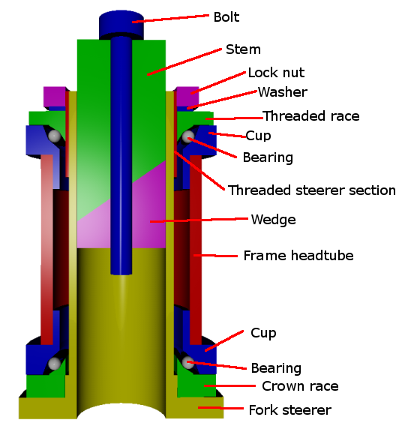Threaded Headset [b]
Threaded headsets are very similar to wheel hubs and cup-and-cone bottom brackets. There is a locknut that holds a cup in place. This cup is threaded until it is tight enough to hold the bearings in place. The cup and crown race servicing is the same as on a threadless headset. Adjustment and service is very similar to a cup-and-cone bottom bracket:
- Remove the stem by loosening the top bolt 2 turns. If the stem is to tight to remove tap the top of it with a hammer until it moves. The stem is held in place by the friction between the wedge, the stem, and the steerer tube.
- Remove the lock nut with a large wrench.
- Remove the threaded race with a headset wrench.
- The fork can now be removed along with the cups, bearings, and crown race (see “Threadless headset servicing and bearing removal”)
- Lube and reinstall the bearings, cups, fork, and crown race.
- Thread the threaded race onto the steerer tube until there is no play in the bearings, then back it off a small amount( 1/8 to 1/16 of a turn).
- Tighten the locknut onto the fork until it locks the threaded race securely. Verify that there is no play in the headset by rocking the bike back and forth.

Handlebar Introduction
All Bicycle handlebars work in the same way. They are composed of a tube or set of tubes that attach to the bike via the stem. At either end of the handlbars grips are attached to aid in comfort and safety. Often brake levers, shifters, lights, and bells are attached to handlebars.

Handlebar Replacement
- Remove the bar-ends. Bar ends protect the rider from injury and should always be replaced.
- Remove the grips. There are 2 ways to do this:
  - Blow air under the grip with an air compressor and pull the grip off.
  - Work a wet screwdriver under the grip and rotate the screwdriver around the handlebar; this lubricates the surface between the grip and the handlebar allowing the grip to be removed.
- Remove all brake levers, shifters, etc. These are typically removed by loosening a bolt on the base of the accessory.
- Loosen the bolt(s) that hold the handlebars onto the stem.
- Remove and replace the handlebars.
- Tighten the bolt(s) that hold the handlebars onto the stem.
- Attach accessories.
- Attach grips by lubricating them with hair spray or water.

Credits
[a] http://en.wikibooks.org/wiki/File:Br_aheadset.png
[b] http://en.wikibooks.org/wiki/File:Br_threadedheadset.png
[c] http://en.wikibooks.org/wiki/Bicycles/Maintenance_and_Repair/Headsets/Headset_Overhaul

